Selecting Titles for Order in GOBI

Searching by Title, Keyword, or ISBN

- Log into GOBI – http://gobi3.com
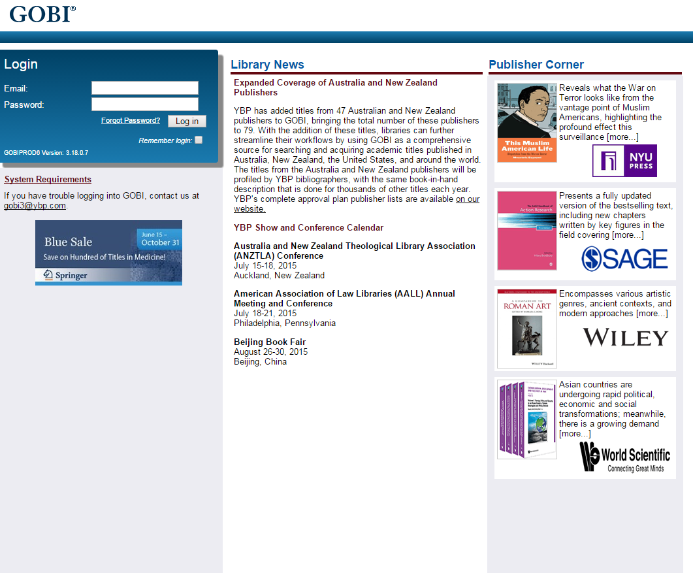

- Perform a simple search via Keyword, Title, ISBN, Author/Editor, Subject, or Keyword + TOC by using the search bar (a) with the drop down menu (b) at the top of the screen.
(a)
(b)
- A more thorough search can be performed by clicking on the search tab (c), and selecting “standard” (d). This will pull up the standard search screen (e).
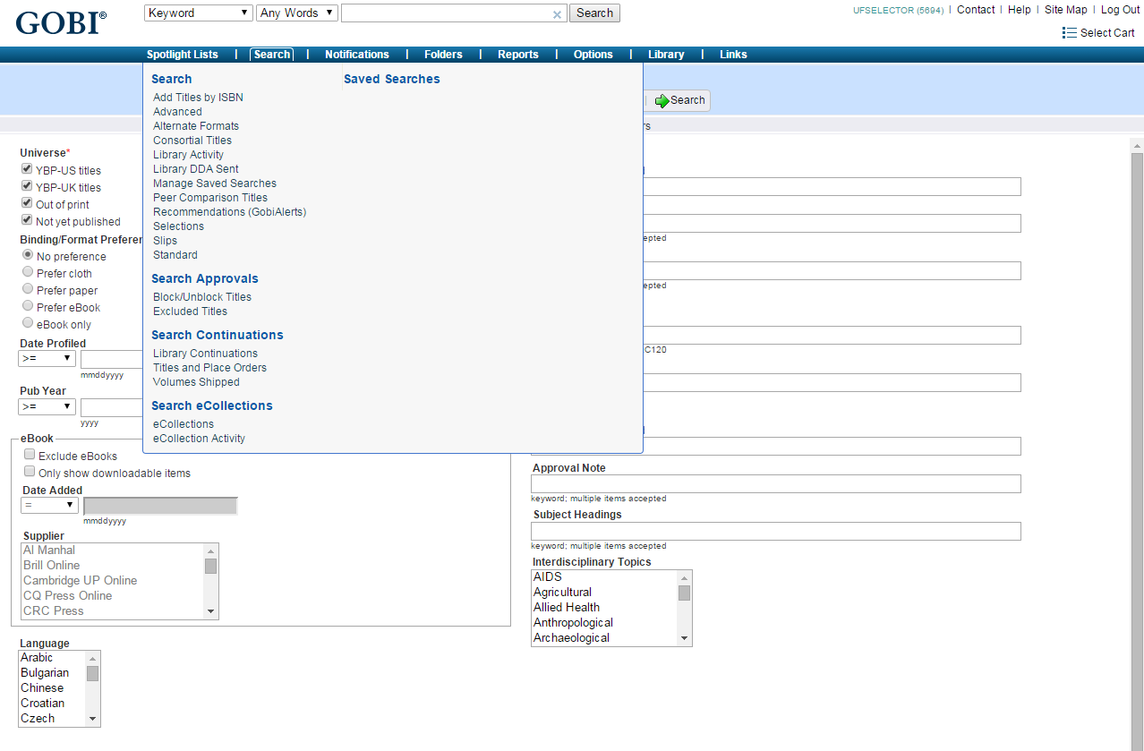
(e)
(d)
(c)

- For this example, a title was input on the standard search screen. The title was typed into the title search box, and “Begins” was selected (f).To complete the search, select the Search button with the green arrow at the top right of the screen (g).
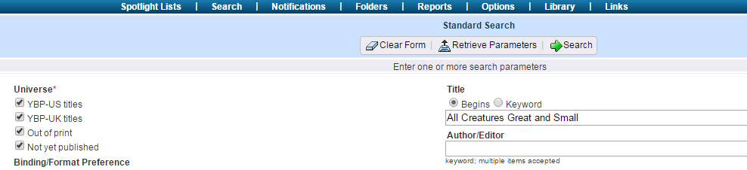
(g)
(f)

- In the search results list, you must now decide which title(s) you want to add to your select cart. To mark a title for selection, click on the left margin of the desired record (h). This will turn the margin blue (i). Once you have selected all of the titles that you would like to add to your select cart (all of these titles should show a blue bar in the left margin), hit the “Add to Select Cart” button at the top left of the screen (j).
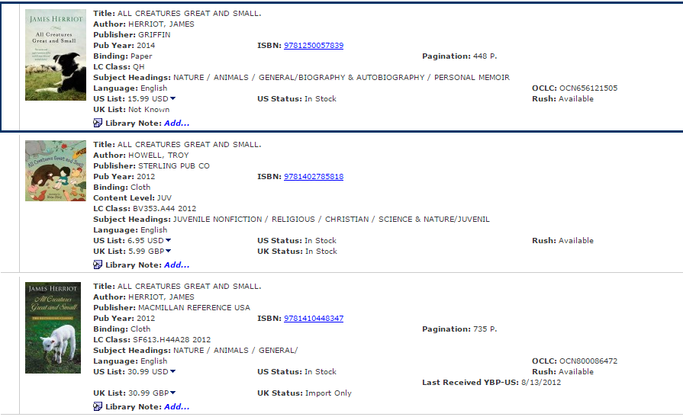
(h)

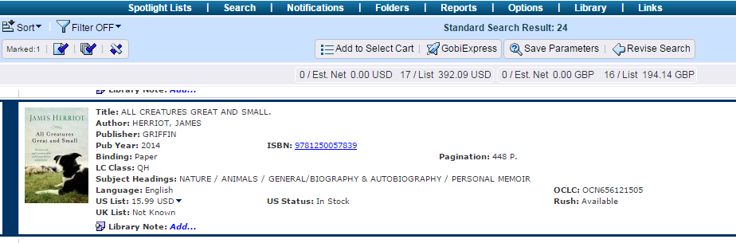
(i)
(j)

- Once you hit the “Add to Select Cart” button, a hand (k) will appear in the margin of the records that were added to your select cart.
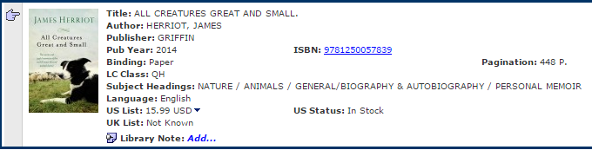
(k)

- Next, you need to provide order details for the titles you have selected. This is done by first clicking on the “Select Cart” button at the top right of the screen (l).
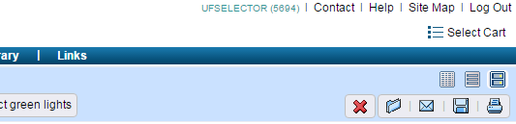
(l)

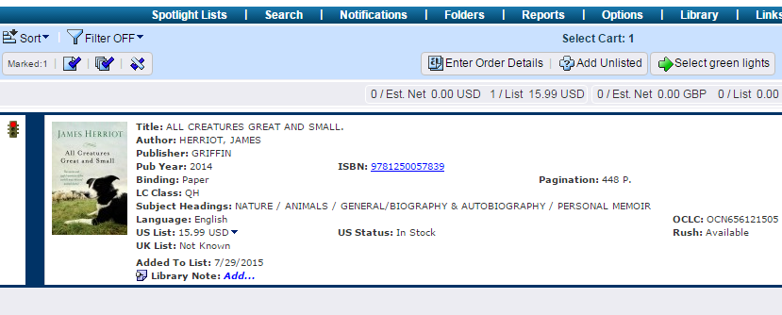
- Once you are on the select cart screen, you will see a red stoplight (m) in the margins of any records you have selected. This means the record is missing its order details. The next step is to select all of the records that you want to enter order details for. Again, you select an item by clicking in the left margin of the record, which highlights the margin blue (n). Once you have selected all of the desired items, click the “Enter Order Details” button at the top of the screen (o).
(o)
(n)
(m)

- An “Order Details” pop-up window should appear (p). Next, choose the appropriate order template from the “Choose Template” drop-down menu (q). The subaccount (r), budget (s), location (t), and your initials (u) should be populated. *Be sure to choose an E-Book template for e-book format requests and a print template for print format requests. Once the correct order details are filled in, select the “save” button at the bottom of the window (v).
(v)
(r)
(u)
(s)
(t)
(q)
(p)

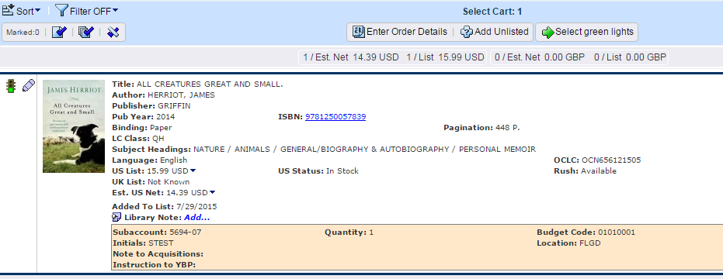
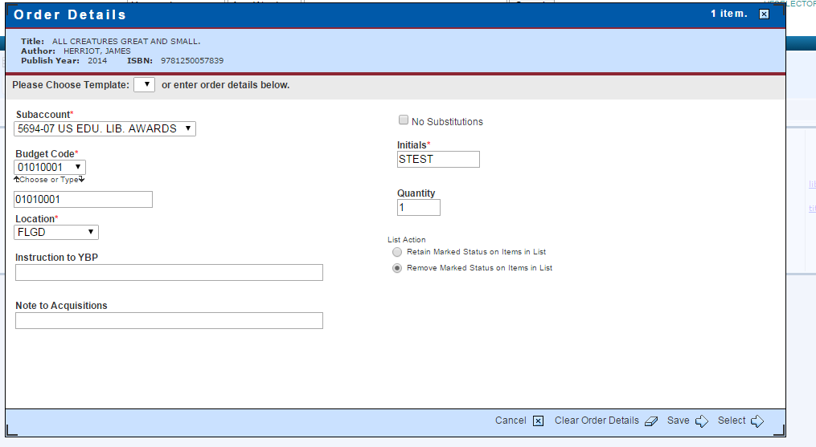
- After the order details are saved, the stoplight in the margin of your selected titles will turn green (w). Click the “Select Green Lights” button (x) at the top of the screen to send your titles to Acquisitions.
(x)
(w)

- After you hit the “Select Green Lights” button, you will return to your select cart. There will be red text at the top of the records that were selected that reads “Selection Acknowledgement” (y). This indicates you have successfully requested a title. This transaction acknowledgment will stay for 7 days and will then disappear from your select cart.
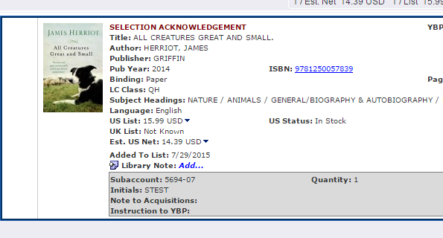
(y)

Changing Your Preferences

- As seen in step 11 above, you will notice that a selection acknowledgement header will appear on records once you have finished selecting them. You can choose to either not receive this acknowledgement at all, or to see it for a longer period of time. To change your preferences, first click on the options tab (a) at the top of your screen. Then select “My Preferences” (b).

(b)
(a)

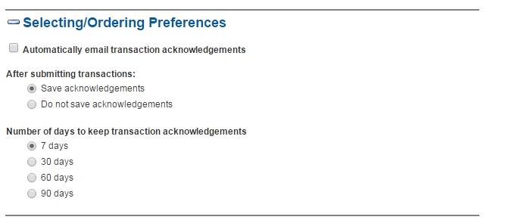
- Scroll down to the section headed “Selecting/Ordering Preferences.” Here you can decide if you want to save your transaction acknowledgements or not. If you choose “Do not save acknowledgements” (c), then once you finish selecting a title, it will disappear immediately from your select cart. If you do want to save your acknowledgements, you can then choose how long you want them to stay in your select cart: either 7, 30, 60, or 90 days (d). “Do not save acknowledgements” is the normal default applied to each account when created.
(d)
(c)

